October 21, 2015
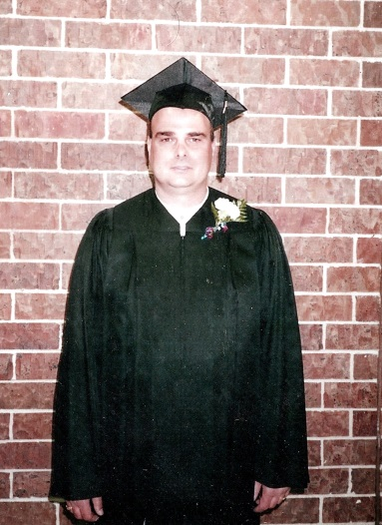
Robert Fitch, 51
“Uncle Bobby”
Archer Daniel Midland Co. in Lincoln, Nebraska
By Tonya Ford, Niece
USMWF Family Member

On that cold, brisk January 29, 2009 Robert Fitch went to work at Archer Daniel Midland Company in Lincoln, Nebraska as he had done nearly every day for the last 32 years. He and his brother in-law were the first ones’ in the door, clocking in to begin their work day, making a living, putting a roof over their families’ head, clothes on their backs and food and their stomachs. However that day would end differently and would be the last day that they greet each other in the morning at the beginning of their work day.
At approximately 8:45am Robert Fitch or as I know him as, “Uncle Bobby” would be heard for the last time over the walkie talkies only to tell his co-workers that he was going to head to his 15 minute break and will be back. At approximately 9:00am his co-worker, friend and brother in-law came to one of the five belt operated manlift devices in the company and noticed that it was still running yet nobody was on the mechanical device and knew immediately that something was not right. He stepped onto the device and what he would come across would forever change his and his family’s life.
It is believed that at 8:45am my Uncle Bobby stepped onto the hazardous device known as the belt operated manlift in the ADM Milling Co. at which time it is unclear what exactly happened however my Uncle Bobby fell off of the device falling approximately 40ft landing onto a large air duct unit disconnecting it from the cement building foundation. Upon disconnection from the building my Uncle slid off of the device onto the cement level below however, it is believed that the belt operated manlift pushed Uncle Bobby through the man hole in which the belt operated manlift device goes through at which time he fell an additional 40ft bouncing off of the cement walls in the construction of the grain building until he came to his resting spot at ground level. His brother in-law attempted CPR on his friend and family member however there was nothing that could have been done as every bone was broken in my Uncle’s body except for his right pinky.
Federal OSHA investigated the incident and proposed a $12,500.00 penalty for three serious violations. However, as part of an informal settlement between OSHA and ADM, the two citations related to the manlift and the monetary penalties were DELETED.
When we asked why, OSHA told us that these dangerous manlifts were not covered by an OSHA’s standard. Under an OSHA standard issued in 1971 (29 CFR 1910.68.), manlifts installed prior to August 1971 were “grandfathered in,” meaning the OSHA standard did not apply to them.
I cannot personally tell you how my family was financially impacted by my Uncle’s loss because I was his niece, however I can tell you that our family is no longer complete as we are missing our Uncle, Brother, Dad, Brother In-Law and Friend. When you lose a loved one so tragically you learn to deal with who you become, you never get over, you never forget you move on day by day and learn to live with who you are.
Since the loss of my Uncle I have been honored to work with families all across Nebraska and the United States that have lost their loved ones due to a work related incident. I have heard their loved ones stories and have cried right beside them for their loss and have seen how their lives have forever been affected by their loss. I have also heard how companies believe OSHA and Worker’s Comp is hurting them…….. the multibillion dollar company that my Uncle worked for when he was killed is still a multibillion dollar company today, they replaced my Uncle with another worker within days of his death, we as a family will never replace Uncle Bobby, a family member is irreplaceable.
Safety should never been a second thought. A worker should know their rights, not have the fear of losing their job if they were to stand up for their rights and going to work should not be a grave mistake. Together we all can make a difference.

